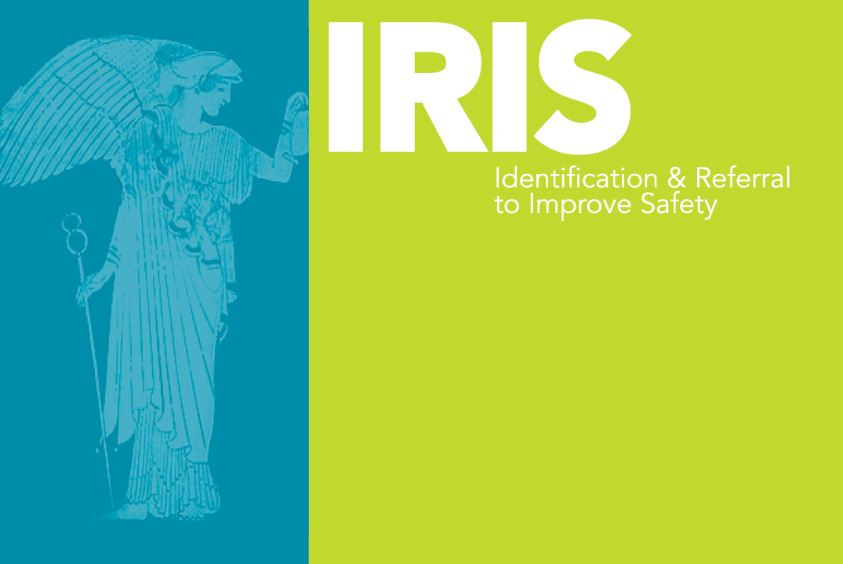

IRIS Training Attendance Record – C1 Training

Practice:………………………………………….............................................................. Date of training session:………………………….….………

Trainer(s): …………………………………………………………………………………….

Name | Gender | Signature | Clinical Discipline  (eg. Partner,GP, PN, HCA, Safeguarding Lead) | E-mail address

